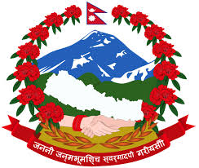
"International Conference on Food Sovereignty and Peasants' Rights"
Date : 2075/11/26-28 (March 10-12, 2019)
Venue : Yellow Pagoda Hotel, Kantipath, Kathmandu.
Organizer : National Farmers' Commission,
Hariharbhawan, Lalitpur.

